freETarget
FreeETarget Competition Target Product Description

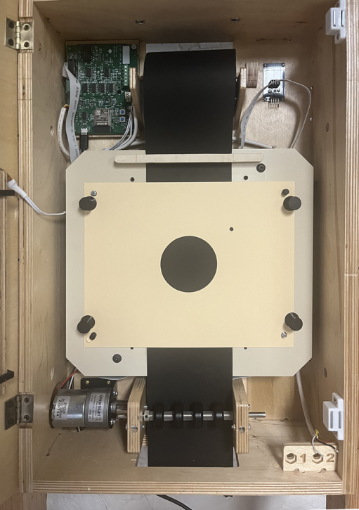
INTRODUCTION
FreeETarget is an open-source project to make an affordable electronic target. FreeETarget is used by a number of international athletes around the world. To make it accessible FreeETarget is offered as a Competition Target, a complete kit that can be assembled locally. Note: region specific parts such as power supplies are not include and must be purchased locally.
FreeETarget works by the electronics ‘listening’ for the sound of the pellet tearing the paper. This sound is analyzed and a pellet location computed. The shot is then sent to the PC client which presents the user with a target image and score.
CONTENTS
The kit is made up of the following parts:
- Housing - Six plywood parts that assemble into the housing
- Circuit – The electronics consisting of the main circuit, four sensors, and a cable harness
- Piece parts – Including screws, nuts, and plastic parts
- Witness paper drive – Electric motor and frame to pull the witness paper
- Target face plate – Steel plate used to hold the target in place.
NOT INCLUDED
Region specific or heavy parts are not included
- 12Volt supply for LEDs and motor
- Illumination LEDs
- USB or similar cable
- Pellet trap
- PC client. Free download at https://free-e-target.com/downloads/#PCClient

ASSEMBLY
The kit is assembled at home using standard hand tools that are in the athlete’s toolbox.
- Assemble the housing
- Install the circuit
- Attach the wiring
- Install at the location
- Download and install the PC software

OPERATION
IMPORTANT. The target must be used in a safe manner, consistent with any other shooting sport.
The target is set at at a distance of ten (10) meters and connected to the PC client either by USB cable or WiFi. Launch the PC client and connect to the target.
There is no direct connection to the firearm in the sense of any technical interference. The product has no relevance under firearms law and, in particular, is neither an essential part nor an accessory that can influence or alter the function, performance, or dangerousness of a firearm.
It is used exclusively for sport training.

MORE INFORMATION
More information can be found on the website free-e-target.com
- Technical Support -Detailed technical information https://free-e-target.com/service-documents/
- Community Made Parts – Drawings, CAD files and other information needed to make FreeETarget locally
- User Stories – How people build and use FreeETarget in their country

